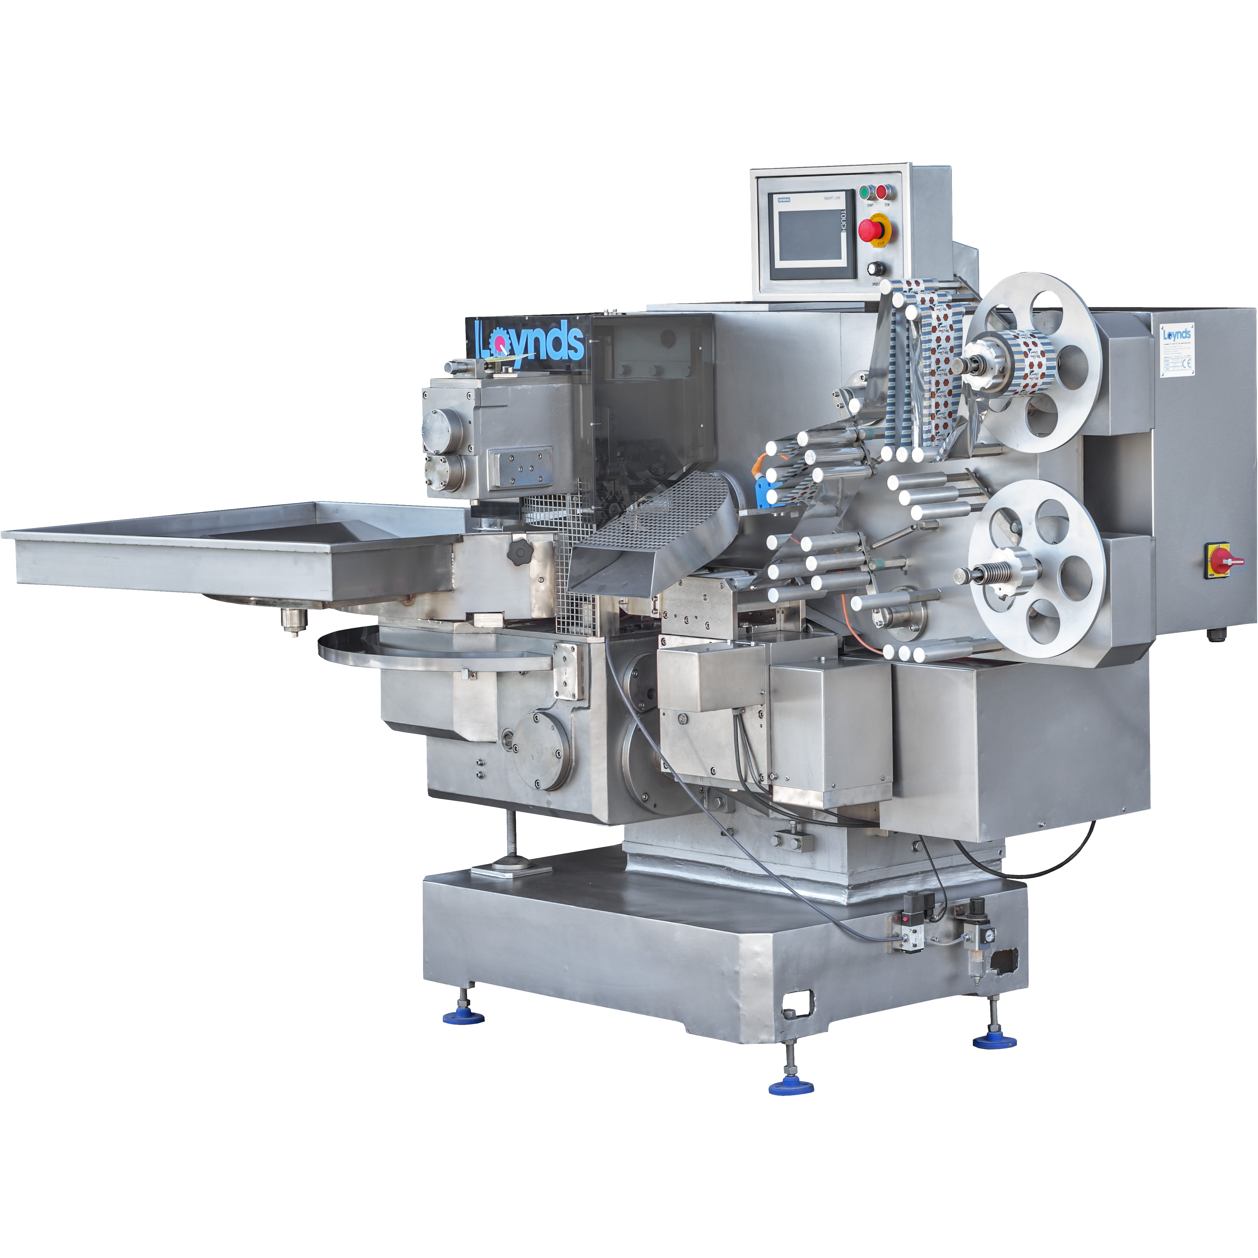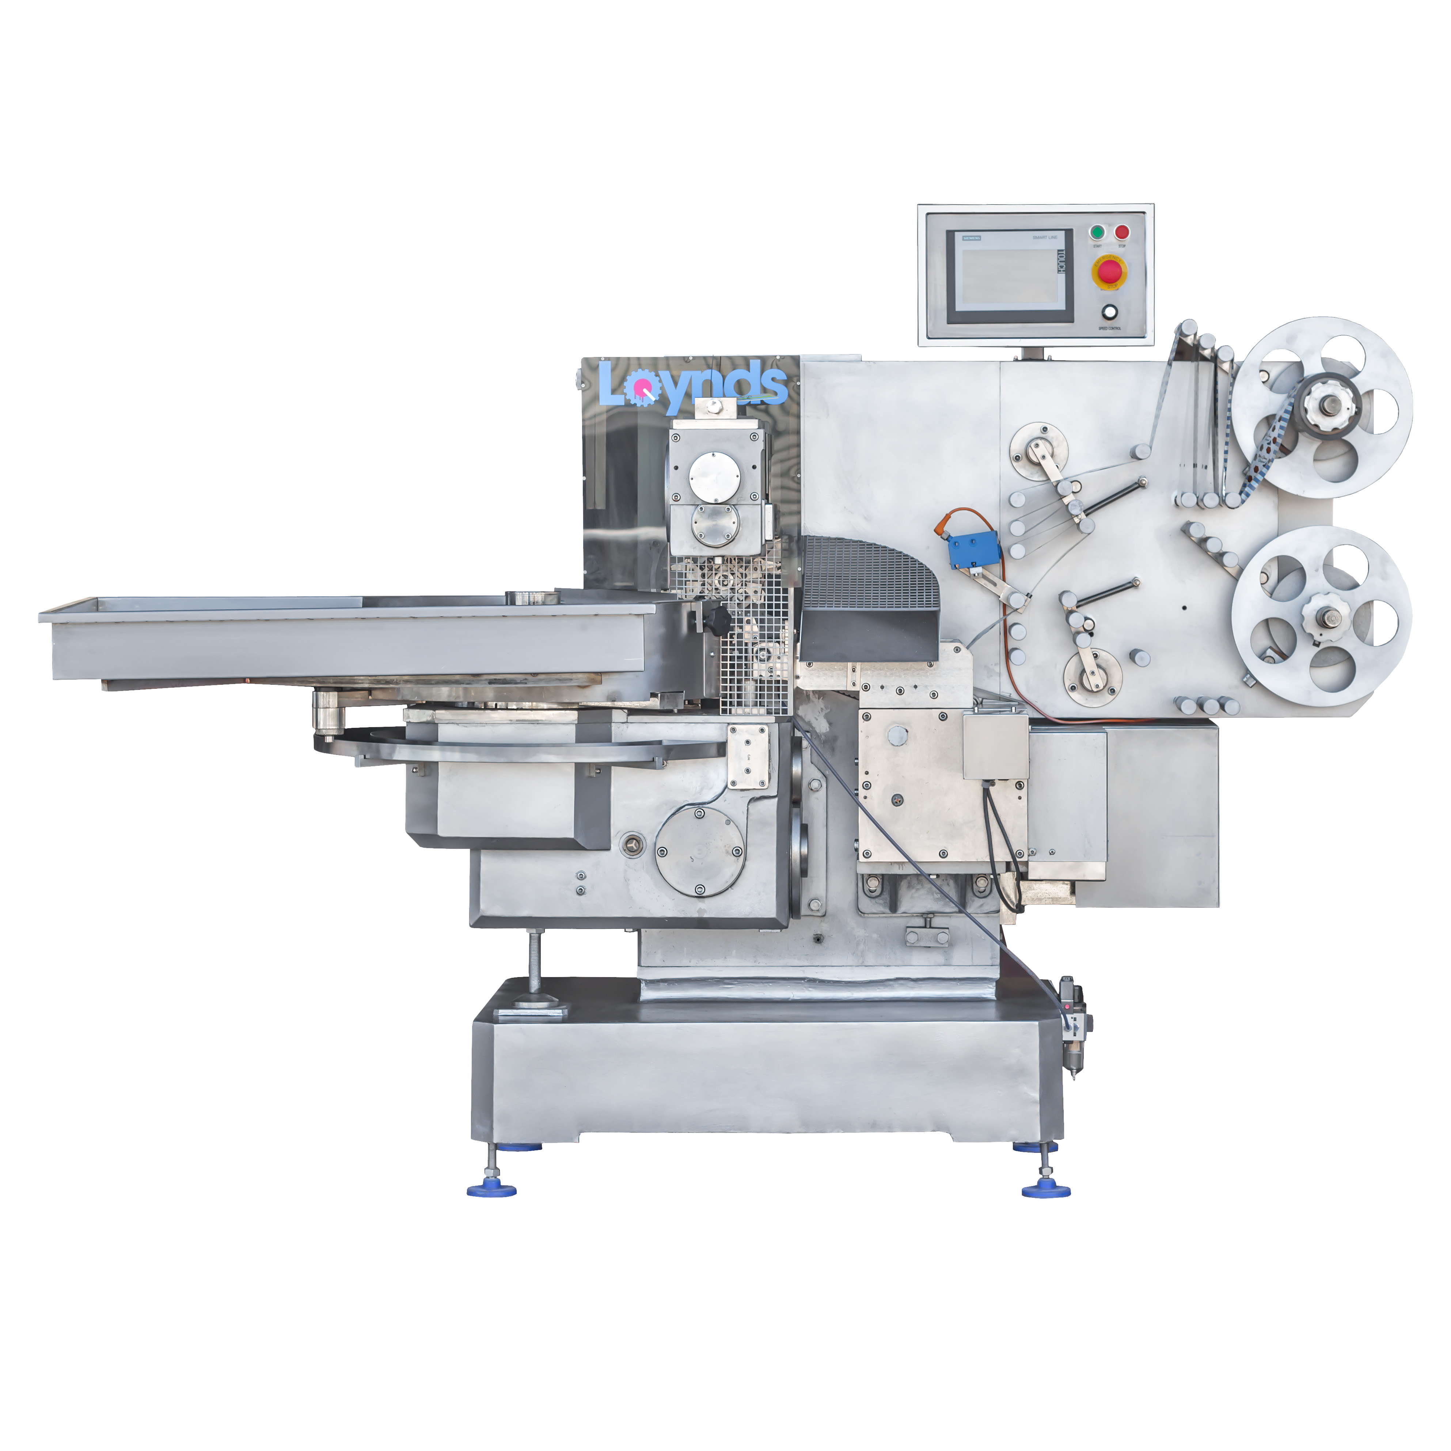

Our Double Twist Wrapper machine takes the candy product and wraps it with a twist on either side. This produces a familiar and classic style sweet wrap that’s been around for decades and continues to be popular today.

Electronically interlocked guarding system with magnetic safety switches ensure that if the guards are opened whilst the machine is running, the machine will automatically stop.  
The double twist wrapper is complete with a free-standing vibratory feeding unit. A machine is permanently on demonstration in our UK showroom.

We can now supply the machine in a belt feed model, if you require. When working in conjunction with a bowl/aligner feeder, the machine can be set into production with flat bottom chocolates and delicate products such as fudge and jelly.

Capable of wrapping sweets within the following ranges: L:12-34mm W:12-34mm D:6-20mm

Our Double Twist Wrapper machine takes the candy product and wraps it with a twist on either side.

Wrapping Process Equipment

Double Twist Wrapper

Features

* A double brush feed plate system.
* A double paper feed reel holder for inner wrap/quick changeover of reels.
* An air-assisted paper feed system.
* An electronic optical eye for ‘no product, no film’ sensing.
* Lexon clear guards for the ultimate protection of the operator.

Options

* Aligner Feeder
* Belt Feed
* Plate Feed
* Vibratory Bowl with Belt Infeed

1790mm

1500mm

<https://youtu.be/DyPjTqNVCHI> <https://youtu.be/3eslCL8qxNM>

<https://youtu.be/ESirH8vL9qQ>

<https://youtu.be/YfQzp3KOMfc>

<https://youtu.be/cPN_ga5dTmY>

**Overall Height**

1500mm

**Overall Length**

1790mm

**Overall Width**

915mm

**Material**

Painted Frame, Stainless Steel Contact Parts

**Output**

Max 480 per minute depending on product and feed configuration

**Weight**

900kg

**Uses**For the automatic vibratory-fed wrapping of pre-formed candies in a double twist wrap.

Double Twist Wrapper

Specifications